**Kaohsiung Museum of Fine Arts - KSPACE**

**Exhibition Open Call Guidelines**

1. Purpose: To highlight the city's creative spirit and diverse artistic expressions, encouraging local creations and artistic energy inspired by Kaohsiung.
2. Project Name: KSPACE
3. Organizer: Kaohsiung Museum of Fine Arts (hereinafter referred to as "KMFA")
4. Exhibition/Performance Categories: No restrictions.
5. Exhibition/Performance Venue: The KSPACE in Kaohsiung Museum of Fine Arts will be the primary space for the exhibition and performance projects. Please refer to the attached document for space dimensions.
6. Exhibition Period: Once a project passes the review, KMFA will arrange the schedule based on the nature of the creation, with a general duration of 6-8 weeks (performance-based projects are not subject to this limitation).
7. Application Deadline: Applications must be submitted before May 1st each year. KMFA will hold a review meeting in June annually. KMFA reserves the right to adjust the schedule and venue allocation as needed and will announce any changes accordingly.
8. Eligibility:
   1. Applicants must meet at least one of the following criteria:
      1. Born in Kaohsiung City.
      2. Currently registered as a resident in Kaohsiung.
      3. Have lived in Kaohsiung for more than one year or use Kaohsiung as the main inspiration for their creative work.
      4. For group (joint exhibition) applications, at least two-thirds of the participants must meet one of the above criteria.
   2. Applicants will not be accepted under the following circumstances:
      1. Having exhibited at KSPACE within three years.
      2. Having exhibited at any venue under the Kaohsiung City Cultural Affairs Bureau within the past two years.
      3. Cultural and art clubs or graduation exhibitions from school or institution at any level.
      4. Any individual or group that has violated KMFA’s venue regulations or copyright laws within the past five years.
   3. For group applications, the applicant must also be one of the exhibitors.
9. Application Procedure:
   1. Please visit KMFA's official website for the implementation guidelines (www.kmfa.gov.tw).
   2. Submit application materials by registered mail or in person to:

KSPACE, Kaohsiung Museum of Fine Arts

Contact: +886-7-5550331 (Exhibition Department)

Address: No. 80, Meishuguan Rd., Gushan Dist., Kaohsiung City 804407, Taiwan

1. Required Application Materials:
   1. KSPACE Application Form (see Annex 1).
   2. List of Works, including artist name, artwork title, year, dimensions, media, and insurance reference value (see Annex 2).
   3. Exhibition/Performance Proposal (up to 3,000 words) (see Annex 3).
   4. Exhibition/Performance Layout Plan (refer to Annex 4 for venue floor plan).
   5. Digital files of all proposed works (file format specifications in Annex 5).
   6. Proof of eligibility:
      1. Applicants qualifying under criteria 1 or 2 must provide a copy of their ID (front and back).
      2. Applicants qualifying under criteria 3 must submit a signed declaration (Annex 6).
   7. Supplementary materials (optional), such as artist resumes, exhibition history, work descriptions, portfolios, activity plans, presentations, or multimedia files supporting the proposal.
   8. All submitted materials will not be returned; applicants should keep a copy for their records.
2. Review Process: The selection process consists of two stages:
   1. Eligibility Review– Conducted by KMFA.
   2. Jury Review: A panel of experts appointed by the Museum will evaluate applications based on electronic submissions.
3. Rights and Responsibilities:
   1. Contract Signing:

* The selected applicant must sign a contract at least three (3) months before the scheduled opening date.
* If unable to proceed with the exhibition, applicants must notify KMFA at least four months in advance in writing and obtain written approval from KMFA.
* Failure to sign the contract within the required timeframe will be considered a withdrawal, and the applicant (individual or group) will be barred from submitting the same proposal to KSPACE for five years.
  1. Funding Support:
     1. For Exhibition:
* Exhibition period: 6-8 weeks
* KMFA provides venue, installation assistance, and promotional printing subsidies up to NT$160,000 (reimbursed upon receipt submission).
* Other exhibition expenses must be covered by the applicant.
  + 1. For Performance-Based Projects:
* KMFA provides venue and a performance subsidy up to NT$80,000 (reimbursed upon receipt submission).
* Other performance-related expenses must be covered by the applicant.

1. Additional Provisions:
   1. By submitting an application, the applicant agrees to all terms stated in these guidelines.
   2. Any unresolved matters will be discussed and agreed upon by KMFA and the applicant.
   3. KMFA reserves the right to amend, suspend, or terminate these guidelines as necessary.

Annex 1

**Kaohsiung Museum of Fine Arts – KSPACE**

**Resume of Artist/ Applicant**

|  |  |  |  |  |  |  |  |  |
| --- | --- | --- | --- | --- | --- | --- | --- | --- |
| Name: | | | | | | Date of Birth: (mm/dd/yy) | | |
| Passport No: | | | | | | Nationality: | | |
| Address: | | | | | | | | |
| Tel: (o) (H) | | | | Cell phone: | | | E-mail: | |
| Occupation: | | | | | | | | |
| Education and Professional Training | | | | | | | | |
| School | | | Major | | Degree | | | Year |
|  | | |  | |  | | |  |
|  | | |  | |  | | |  |
| Experiences | | | | | | | | |
|  | | | | | | | | |
|  | | | | | | | | |
| Important Works (Exhibitions/Publication and Paper) | | | | | | | | |
| Year | Exhibitions/Publication and Paper | | | | | | | |
|  |  | | | | | | | |
| Awards & Prizes | | | | | | | | |
| Year | Name of the awards | | | | | | | |
|  |  | | | | | | | |
| Copy of Both Sides of ID card/Passport | | | | | | | | |
|  | | | | | | | | |
| Participating Members (For group applicants, please list the names of participants and one key exhibition record. Individual applicants do not need to fill out this section.) | | | | | | | | |
| Name | | Exhibitions/Publication and Paper | | | | | | |
|  | |  | | | | | | |
|  | |  | | | | | | |
| I hereby declare that the information filled in the application form and the attached application materials are true and correct.    （Signature for consent）  Application Date： 　　Year　 　 Month　 　 date | | | | | | | | |

(If the space provided is insufficient, please add additional pages as necessary.)

Annex 2

page 1

|  |  |  |  |  |  |  |  |
| --- | --- | --- | --- | --- | --- | --- | --- |
| **KSPACE – List of Works** | | | | | | | |
| **Project Title** | | | | | **Total Number of Works** | **Number of Participants** | |
| No. | Artist | Title | Year | Media | Dimensions (L×W×H cm, including frame) / Video Length (min:sec)  *Max Weight of Each work ≤ 100kg | insurance value (NTD) | Collector |
|  |  |  |  |  |  |  |  |
|  |  |  |  |  |  |  |  |
|  |  |  |  |  |  |  |  |
|  |  |  |  |  |  |  |  |
|  |  |  |  |  |  |  |  |
|  |  |  |  |  |  |  |  |
|  |  |  |  |  |  |  |  |
|  |  |  |  |  |  |  |  |
|  |  |  |  |  |  |  |  |
|  |  |  |  |  |  |  |  |
|  |  |  |  |  |  |  |  |
|  |  |  |  |  |  |  |  |
|  |  |  |  |  |  |  |  |
|  |  |  |  |  |  |  |  |
|  |  |  |  |  |  |  |  |
|  |  |  |  |  |  |  |  |
|  |  |  |  |  |  |  |  |

(If additional rows are needed, please add more as necessary.)

Annex 3

**KSPACE – Statement for Exhibition/Performance**

|  |
| --- |
|  |
|  |
|  |
|  |
|  |
|  |
|  |
|  |
|  |
|  |
|  |
|  |
|  |
|  |
|  |
|  |
|  |
|  |
|  |
|  |
|  |
|  |
|  |
|  |
|  |

(If additional rows are needed, please add more as necessary.)

Annex 4

**KSPACE Gallery Floor Plan**

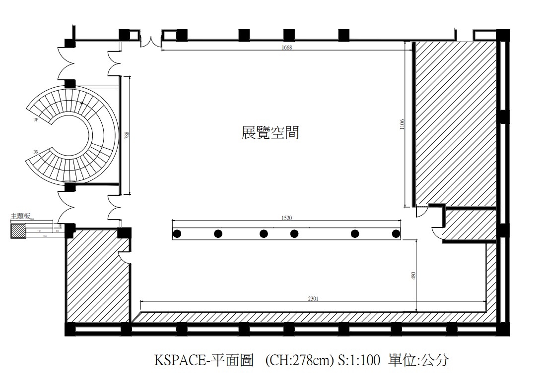

KSPACE Gallery Floor Plan (CH: 278cm) S:1:100 cm

Exhibition Space

Annex 5

**Digital File Format Specification for Application Works**

**(Please carefully read the following instructions before submitting an application. )**

1. Each submitted work must correspond to the numbering listed in the Artwork List (Annex 2).
2. Digital file size must not exceed 2MB per file and must be submitted in JPG format with sufficient clarity for artwork identification.
3. File Format:
   1. Two-dimensional works : One image per piece.
   2. Sculptural works: One full view and three images from different angles.
   3. New media or interdisciplinary artworks:
      * Three screenshots or photos from different angles (JPG, max 2MB each).
      * Video files should be in MP4 format.
      * Sound or music files should be in MP3 or WAV format (CD standard format: 16-bit / 44.1kHz stereo). Please ensure the file is playable on PC or NTSC standard DVD players.
      * The first section of the submitted file should include a one-minute preview of the artwork in its exhibition setting. The second section should contain the full-length video or audio content.
      * Applicants should specify necessary equipment, technique, or spatial requirements, though KMFA retains the final decision on exhibition space allocation.
   4. Artworks in other forms: relevant documents or files.

Annex 6

### Self-Declaration Form

I, ______________, have resided in Kaohsiung City for more than one year and am engaged in artistic creation. I hereby submit the following supporting documents as proof:

☐ House rental contract, proof of homeownership, or documentation proving family-owned residence.

☐ Supporting materials related to work, creation, or artistic activities in Kaohsiung.

☐ Other relevant documents.

All provided information is accurate. If any false information is found, the Kaohsiung Museum of Fine Arts reserves the right to revoke my application.

To: Kaohsiung Museum of Fine Arts

Applicant: ___________________________ (Signature)

ID(passport) Number:

Address:

Contact Number:

Date: ______________________ (M/D/Y)

### Copyright Authorization Agreement

For artworks included in the KPSACE project, please refer to the attached document.

* + - 1. I, the undersigned, confirm that the submitted artworks listed in the attached document have been selected for exhibition at KSPACE, the Kaohsiung Museum of Fine Arts (KMFA). I hereby grant KMFA a non-exclusive license to use the submitted works for the purposes of promotion and educational outreach, free of charge, for the duration of the copyright period. This authorization is granted without restrictions regarding location, time, media, format, frequency, reproduction count, content, and method of use.
      2. The undersigned guarantees that the submitted works are original creations and that they have full rights to provide the aforementioned authorization. Furthermore, the undersigned ensures that the granted rights do not infringe on any third party's intellectual property rights. This authorization is non-exclusive, meaning the author retains copyright ownership over the submitted works.
      3. For collaborative works involving two or more creators, a representative shall be designated as the contact person. All co-authors must sign this authorization agreement to confirm their consent.

To: Kaohsiung Museum of Fine Arts

Signatory (Author/Representative):

ID(passport) Number:

Contact Number:

Registered Address:

Co-Author(s) Signature(s):

Date: ______________________ (M/D/Y)