**2025 Kaohsiung International Container Arts Festival**

**Open Call for Proposals**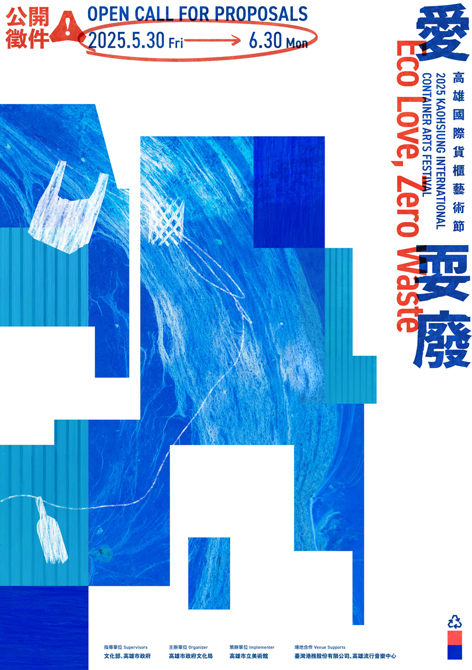

# Purpose

The Kaohsiung International Container Arts Festival utilizes "containers" as a core concept to develop a distinctive festival brand for Kaohsiung. Since its inception in 2001, the biennial festival has showcased creativity while addressing urban issues.

## Organizers

1. Supervisors: Ministry of Culture(Taiwan), Kaohsiung City Government
2. Organizer: Bureau of Cultural Affairs, Kaohsiung City Government
3. Implementer: Kaohsiung Museum of Fine Arts

## Exhibition Dates & Venue

1. Exhibition Dates: December 20, 2025 – March 1, 2026
2. Opening / Press Conference: December 20, 2025
3. Venue: Kaohsiung Harbor No.11 Pier, Kaohsiung Music Center Sea Breeze Plaza

# Submission Guidelines

## How to Submit

1. Submission Period: **May 30 – June 30, 2025**. All proposals must be submitted digitally by **Monday, June 30, 2025 at 23:59 (GMT+8)**. Late submissions will not be accepted.
2. Email submissions to: jin0725@kmfa.gov.tw
3. Please include "2025 Kaohsiung International Containter Arts Festival_group name" in the email subject title.

## Required Materials

1. Basic Information: Please complete the attached form including application team and members, leading architect/artist, designer resume, past works and relevant licenses or awards.
2. Design Proposal: complete the attached form including project title and concept description (Word limit: 300-1,000 words). Implementation details including:
   1. Number of containers needed.
   2. **Basic design drawings** (layout sketches, floor plan, elevation, 3D simulation renderings of both exterior and interior, etc.) **in A3 horizontal format**, including description of the structure and materials used.
   3. Spatial requirements: purpose, number of people, usage, equipment, and special needs.
   4. Estimated costs based on the budget guidelines (please refer to C. III. 10.Production Budget for Physical works)
3. Intellectual Property Rights Statement and License Agreement

# Design Creativity

## Theme: "Eco Love, Zero Waste"

The 2025 Kaohsiung International Container Arts Festival adopts the theme "Eco Love, Zero Waste", promoting marine regeneration and sustainable living while envisioning a harmonious future between the harbor’s environment and culture. The festival highlights the potential of container reuse and regeneration—transforming discarded materials and abandoned spaces to redefine perceptions of "waste" and create new value.

Creative Directions based on the "PORT" concept:

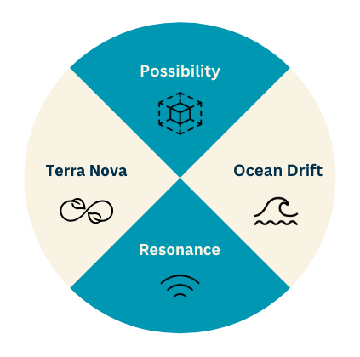

1. **P – Possibility**  
   Abandoned materials mark new beginnings—transform decommissioned containers and recycled materials into a perpetual engine of creativity.
2. **O – Ocean Drift**

Drift represents not loss but discovery. Migration becomes regeneration, and sustainability signifies continuous evolution.

1. **R – Resonance**

Highlighting sound, technology, and nature’s dialogue with the city—making sustainability audible and tangible.

1. **T – Terra Nova**

Create a livable future. Showcase how waste transforms into furniture, fashion, and everyday goods. Emphasize ecological design and green architecture, creating a "breathing oasis" with second-hand containers and reclaimed materials.

## Exhibition Site

Main locations: Kaohsiung Harbor No.11 Pier, Kaohsiung Music Center Sea Breeze Plaza.



## Production Guidelines

* 1. Container Module: Standard 20-foot containers (2.59m high, 6.06m length, 2.44m wide, approx. 14.85 square meters) are to be used.
  2. Design Requirements: Projects must focus on functionality, creativity, feasibility, eco-friendly, safety, inclusivity, and cultural accessibility.
  3. Exhibition Site: Kaohsiung Harbor No.11 Pier, Kaohsiung Music Center Sea Breeze Plaza.

1. The implementer will carry out environmental cleaning around the area based on the actual foundation conditions.
2. The ground is currently paved with bricks, and relevant construction methods should be considered in the design process.
3. The implementer will allocate an electrical box and water valve for each container work in the surrounding area.
   1. Building Base Area: Total occupied space must not exceed twice the size of the container(s) used.
   2. Basic Materials: Use standard containers or the beams, columns, and floor structures of standard containers.
   3. External Space:
4. Considering the movable nature of the container itself, the principle is to avoid digging the foundation of the exhibition site.
5. Stacking is permitted up to two container heights. Disassembly is not subject to the limit.
6. Plan for internal water drainage and plumbing systems should be included in the design proposal. Domestic wastewater drainage systems maybe proposed for on-site treatment design, but they are not included within the scope of the physical container space production.
7. All related structural designs must be submitted by the applicants and approved by a licensed structural engineer, with structural calculations and official certification documents provided. The relevant structural designs need to be submitted by the applicants for calculation by a structural engineer and provide structural certification documents.
   1. Interior Space: Includes building materials, equipment, furniture, and objects required to fulfill specific functions and express core design concepts. For proposals proceeding to physical construction, water supply, wastewater drainage, electricity, and water valve connections must be implemented to ensure the proper operation of interior facilities.
   2. Safety Concerns: Excavation for foundations is not permitted for this exhibition. Considering both the structural nature of containers and the coastal site conditions, proposals must prioritize safety and include certified calculations by licensed structural engineers.
   3. Detailed design guidelines will be specified in the contract.
   4. Production Budget for Physical works:
      1. Design projects will be outsourced by the implementer according to Government Procurement Law, awarded to the applicants who submitted the design proposals. This includes design, construction, supervision, demolition, and license applications (including structural safety calculation reports, structural safety certificates, structural drawings, etc.). The architects and interior design teams must agree to sign a contract with the implementer in accordance with Government Procurement Law.
      2. Production and Budget for Physical Container Works:

* The production budget includes Construction Inspection Fees and Certification Fees by structural engineers.
* The implementer will pay each architectural or interior design team based on the actual production costs, which will be finalized through detailed discussions and signed in the contract.
* The production budget is calculated based on the number of standard containers used:
  + Budget for 3 standard container spaces: NT$1,100,000 (including tax).
  + Budget for 2 standard container spaces: NT$900,000 (including tax).
  + Budget for 1 standard container space: NT$700,000 (including tax).

## Participation and Rights

1. Participation Fee：
   1. selected physical exhibits: The organizer will pay a participation fee of NT$50,000 (including tax) for each selected domestic team, and NT$150,000 (including transportation, accommodation, etc.) for each international team.
   2. selected digital exhibits: The organizer will pay a participation fee of NT$50,000 (including tax) for each selected team, both domestic and international (international teams will be subject to applicable tax rates).
2. Digital exhibits will be displayed at the exhibition venue and will include the design team introduction, roject name, design concept description, design drawings and illustrations, and 3D simulation images (animations). Selected teams must cooperate with the organizing unit to create the display animation.
3. Copyrights, Promotional Materials, and Publication Distribution:
4. The participating teams must obtain the necessary copyrights for any music, images, or other materials used in their creative works. Any disputes regarding copyright will be the responsibility of the participating team.
5. For promotional purposes, the organizer has the right to research, photograph, report, exhibit, print, reproduce, and publish the participating works in relevant promotional materials, magazines, and online platforms, as well as produce e-books.
6. The participating teams authorize the implementer to use the provided text, photos, images, and other materials for the creation of promotional albums, brochures, and other materials during the copyright period of these works, and agree that the organizing team and relevant units can use the materials for educational promotion, including online distribution or public display. If the materials provided by the team infringe upon others' copyrights, the team is fully responsible for any legal issues.
7. Exhibition materials will grant the implementer editorial and modification rights, as outlined in the contract.

# Additional Notes

## Design Proposals Selected for Physical Container works

Selected teams must submit environmental configuration diagrams, detailed construction drawings, structural safety calculation reports, structural safety certificates, structural drawings, estimated costs for construction and materials, construction and transportation planning, and maintenance management recommendations to the implementer. After approval, negotiation and contracting will proceed, followed by execution.

## Disqualification Conditions

Participants will be disqualified and banned from entering the competition for five years under the following circumstances

1. Plagiarism or infringement of intellectual property rights.
2. Violation of any regulations in this guideline.

Submission indicates agreement to all open call terms. The organizer reserves the right to update or revise the guidelines.

# Contact

2025 Kaohsiung International Container Arts Festival Project Team

E-mail: jin0725@kmfa.gov.tw

Tel: +886-7-5550331 ext. 292, 322

| 2025 Kaohsiung International Container Arts Festival |
| --- |
| Application Form |
| Please refer to the following information and provide the required materials when submitting your proposal. |



# Design Concept

1. Title of the Work:
2. Concept Description: (300–1000 words):

# Design and Functional Requirements

Please include planning sketches or diagrams, layout plans, elevations, sections, perspectives, and 3D renderings (exterior and interior). **Drawings should be presented in A3 landscape format, with clear descriptions of structure and materials used.**

1. Number of Containers Used:

This festival adopts the 20-foot standard shipping container as the basic module (each container measures 2.59m in height, 6.06m in length, and 2.44m in width—approximately 14.85 square meters). Proposals may integrate creative media and the container concept for extended design possibilities.

**Production budget is based on the number of containers used for the physical exhibition space:**

* Use of **3 containers**: NT$1,100,000 (tax included)
* Use of **2 containers**: NT$900,000 (tax included)
* Use of **1 container**: NT$700,000 (tax included)

1. Basic Design Drawings
2. Planning Sketches / Diagrams
3. Layout Plan
4. Elevations
5. Sections
6. Perspective Drawings
7. 3D Renderings (Exterior and Interior)
8. Structure and Materials Used
9. Number of Suggested Users
10. Total Area
11. Interaction Design
12. Equipment Requirements
13. Special Requirements / Other Needs
14. Material and Structural System

# Budget Estimation

Please refer to the table below and evaluate your production budget based on the number of containers used. You may expand the table as needed.

| Item No. | Description | Unit | Quantity | Unit Price | Total Price | Remarks |
| --- | --- | --- | --- | --- | --- | --- |
|  |  |  |  |  |  |  |
|  |  |  |  |  |  |  |
|  |  |  |  |  |  |  |
|  |  |  |  |  |  |  |

# About the Project Team

1. Project Team
2. Team Members (e.g., person in charge, lead designer, etc.)
   1. Title
   2. Education
   3. Experience
3. Awards and Honors
4. Team Portfolio / Past Works

**Intellectual Property Rights Statement and License Agreement**

Our team, ____________________, hereby participates in the open call for the 2025 Kaohsiung International Container Arts Festival and confirms that the submitted design proposal titled ____________________ is an original creation by our team. Should any plagiarism or infringement of third-party intellectual property rights be discovered, we accept full legal responsibility. We also agree that the organizer and the implementer have the right to revoke our participation and reclaim all design-related fees and any associated costs.

We agree that, upon selection and confirmation for participation, all intellectual property rights related to the designs— including all charts, texts, audiovisual materials, and any other creative content or concepts generated during the execution of this project— shall be granted as a free, non-exclusive license to the Organizer, Bureau of Cultural Affairs, Kaohsiung City Government and the Implementer, Kaohsiung Museum of Fine Arts, without limitation of territory, time, or method of use.

To

Kaohsiung Museum of Fine Arts

Studio/ Company:

Signature of Responsible Person:

Passport Number:

Address:

Phone Number:

Date: (Year) (Month) (Day)